Step-1 Loading the data
df=spark.read.csv("/Volumes/workspace/default/ecommercedata/data.csv",header=True,inferSchema=True)
df.head()

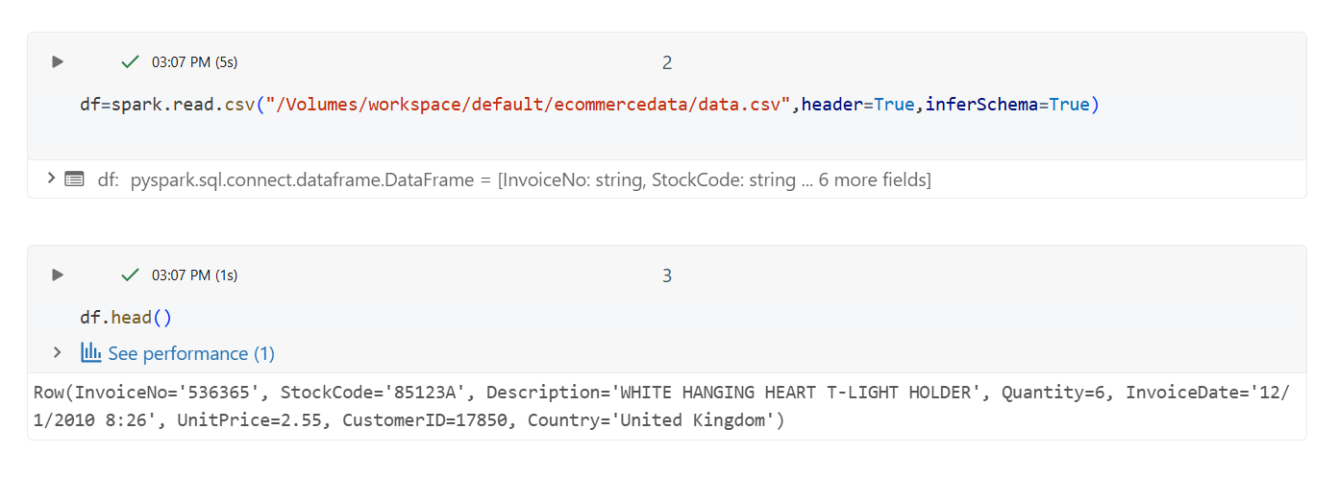
df.count() 541909
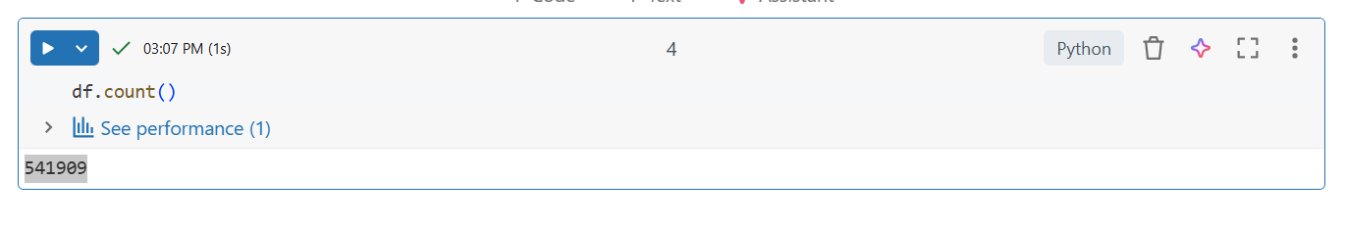
df.show()
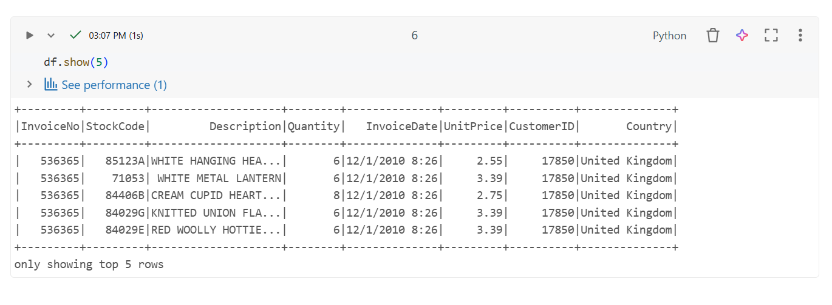

DATA CLEANING
df=df.dropna(subset=["CustomerID"])
df=df.filter(col("Quantity")>0)
df=df.filter(col("UnitPrice")>0)
df=df.filter(col("Description")!="")
df=df.filter(col("Country")!="")
df.count()
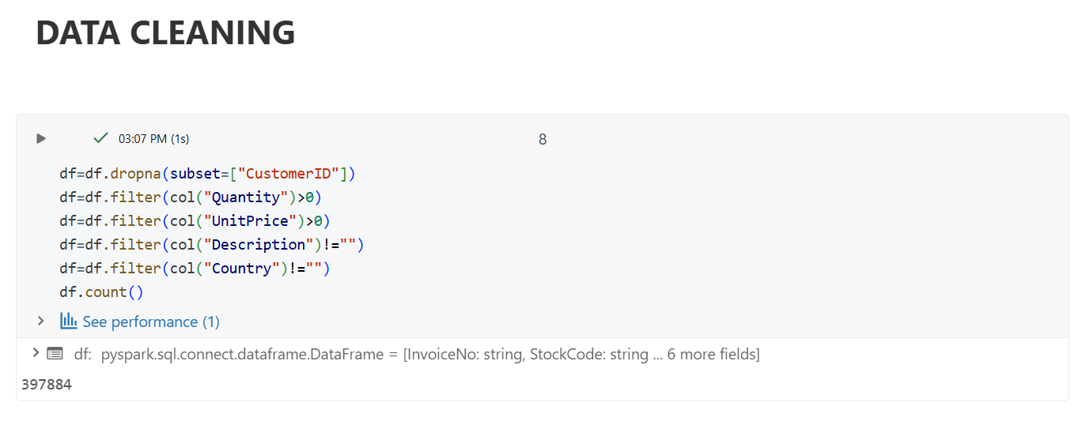
PROBLEM -> Customer with highest & lowest unit price
#Highest UnitPrice
df.orderBy(col("UnitPrice").desc()).limit(1).show()
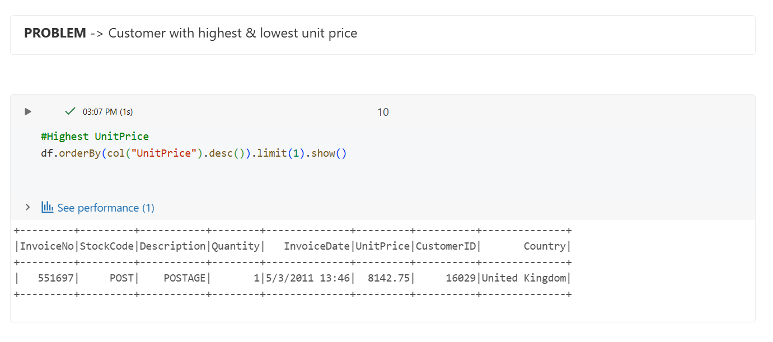

#Lowest UnitPrice
df.orderBy(col("UnitPrice").asc()).limit(1).show()
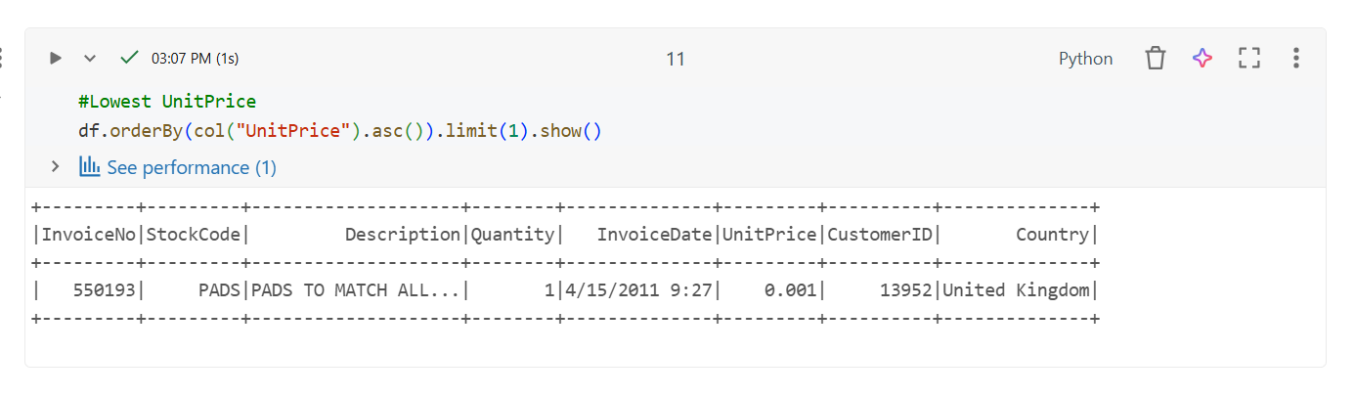
PROBLEM -> Top 5 countries with highest quantity
from pyspark.sql.functions import sum
df.groupBy("Country").agg(sum("Quantity").alias("TotalQuantity")).orderBy(col("TotalQuantity").desc()).limit(5).show()
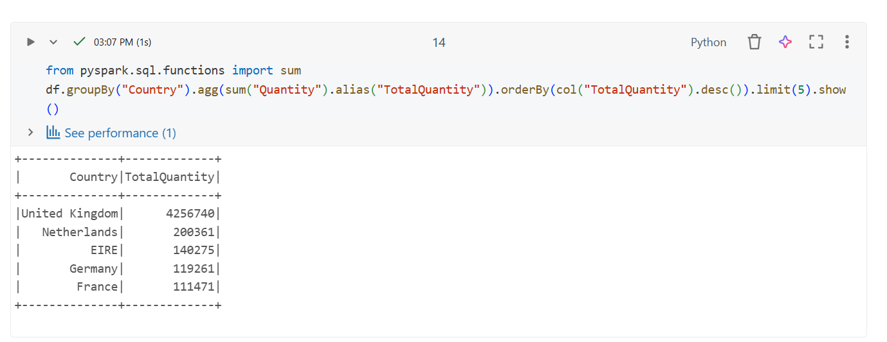
PROBLEM -> Total price of customer (quantity * unitprice)
df.withColumn("TotalPrice",col("Quantity")*col("UnitPrice")).groupBy("CustomerID").agg(sum("TotalPrice").alias("CustomerSpend")).show(5)
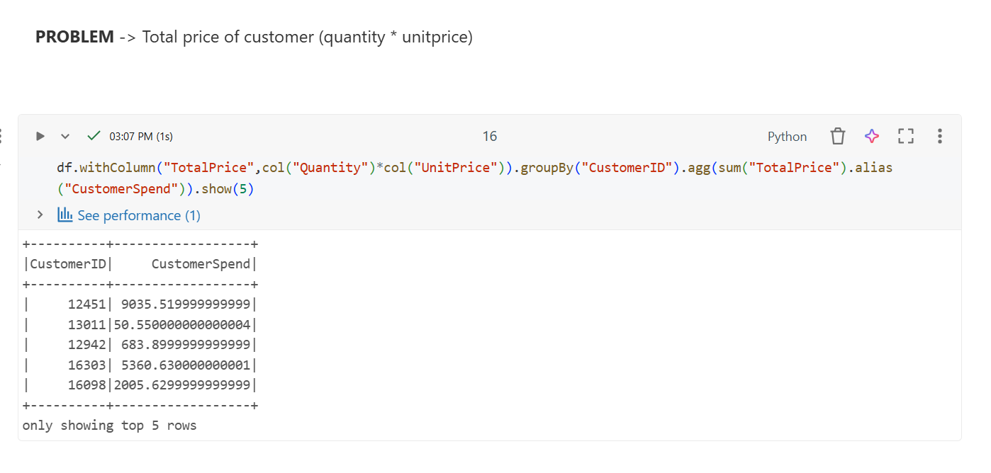
PROBLEM -> Filter quantity between 4 and 9
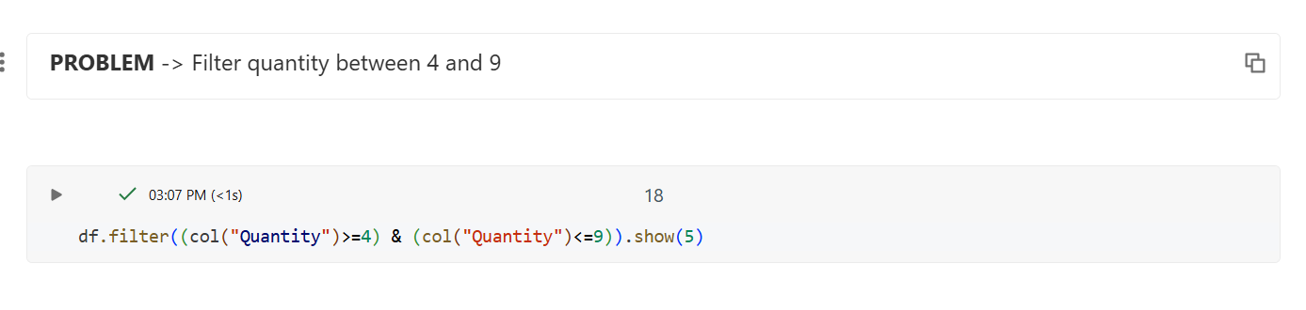
PROBLEM -> Filter customerID = 15862
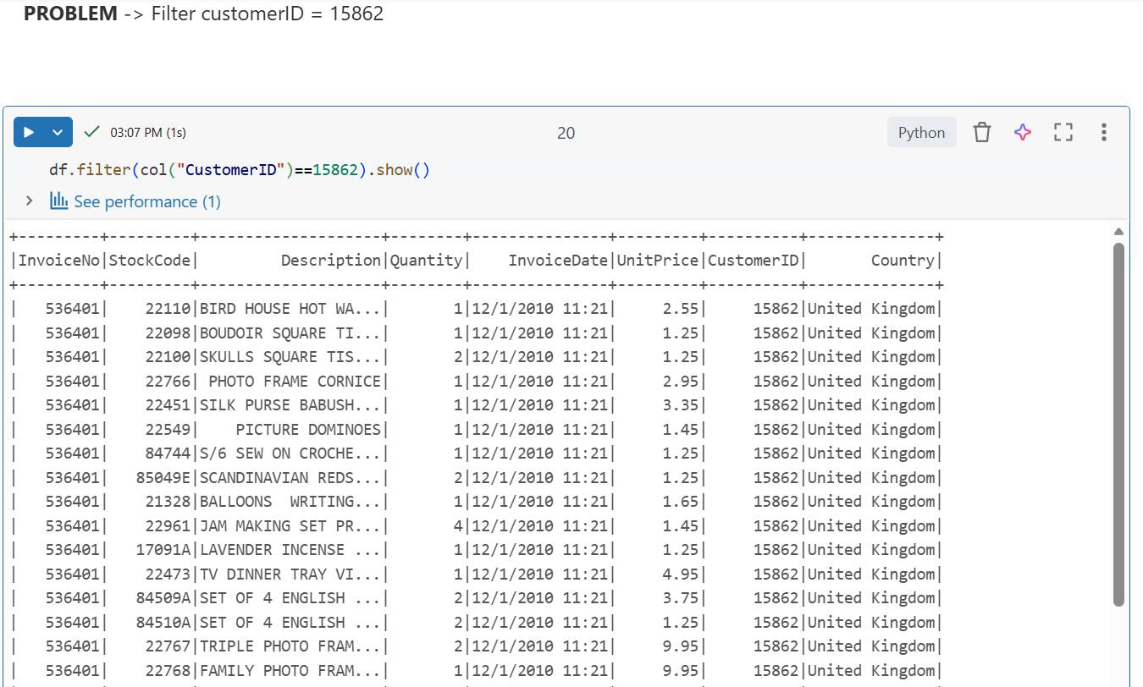

Loading the processed data to dbfs
display(
dbutils.fs.ls("/Volumes/workspace/default/ecommercedata")
)
output_path="/Volumes/workspace/default/ecommercedata"
dbutils.fs.mkdirs(output_path)
df.coalesce(1).write.mode("overwrite").csv(output_path)
display(
dbutils.fs.ls(output_path)
)
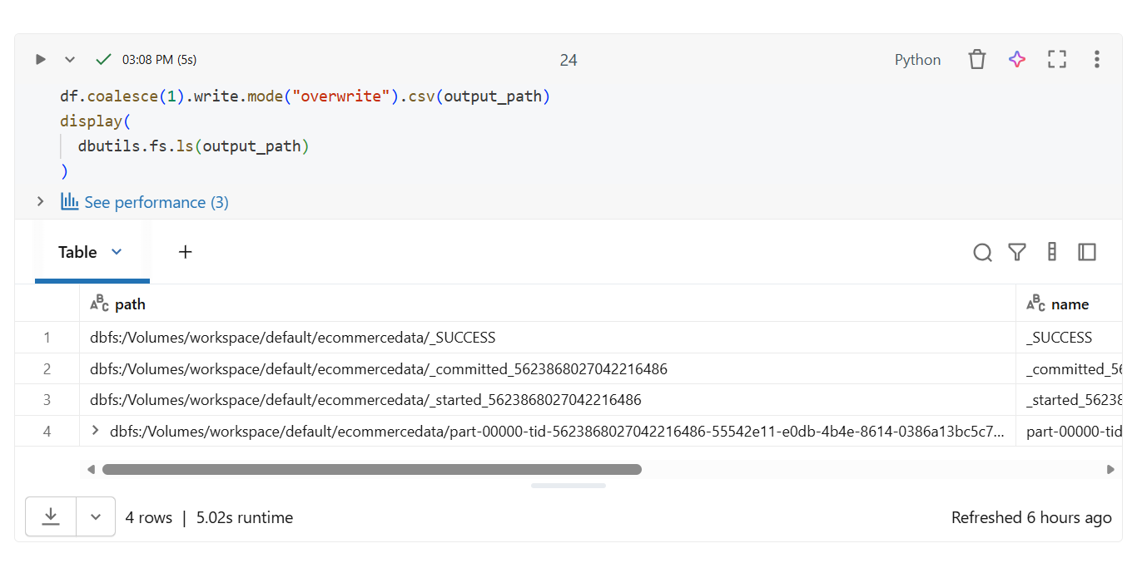

NIFI

NiFi Pipeline – Ingest Processed E-Commerce CSV
Move processed ecommerce data into the pipeline using NiFi and storing it in a output folder
Step 1 – prepare Local Folders
C:\nifi_input
C:\nifi_output
Step 2 – Open NiFi UI
https://localhost:8443/nifi
Step 3 – Create Ingestion Flow
Add processor: GetFile
Add processor: PutFile
Connect: GetFilePutFile
Step 4 – Run the Flow
Start both processors
Step 5 – Validate
C:\nifi_output

KAFKA

Step 1 – setup the environment
Update Ec2 -> Sudo yum update -y
Install Java -> Sudo yum install java-1.8.0-openjdk -y
Download Kafka -> wget https://archive.apache.org/dist/kafka/3.4.0/kafka_2.12-3.4.0.tgz
Extract File -> tar -xvzf kafka
Step 2- Start Zookeeper
bin/zookeeper-server-start.sh config/zookeeper.properties
step 3 – start kafka server
bin/kafka-server-start.sh config/server.properties
step 3- Create the topic
bin/kafka-topics.sh --list --bootstrap-server localhost:9092
step 4 – start producer
cat /home/ec2-user/data.csv | bin/kafka-console-producer.sh --topic ecommerce-data --bootstrap-server localhost:9092
step 5 – start consumer
bin/kafka-console-consumer.sh –topic ecommerce-data –bootstrap-server localhost:9092 –from-beginning
step 6 – upload data.csv to EC2
scp -i C:\Users\SV001089023\Downloads\kafka01.pem C:\Users\SV001089023\Downloads\ECOMMERCE\ECOMMERCE\data.csv ec2-user@3.25.230.156:/home/ec2-user/data.csv

Flink
Step 1 – we have a batch data(data.csv) , load this data to root folder of ec2 instance
Step 2 – start flink, zookeeper, kafka server, topic
Step 2 – Sent data into kafka
cat data.csv | kafka-console-producer.sh --topic ecommdata --bootstrap-server localhost:9092
(kafka became streaming data source, it store and streams data line by line in real time)
Data.csv kafka Topic(ecommdata)
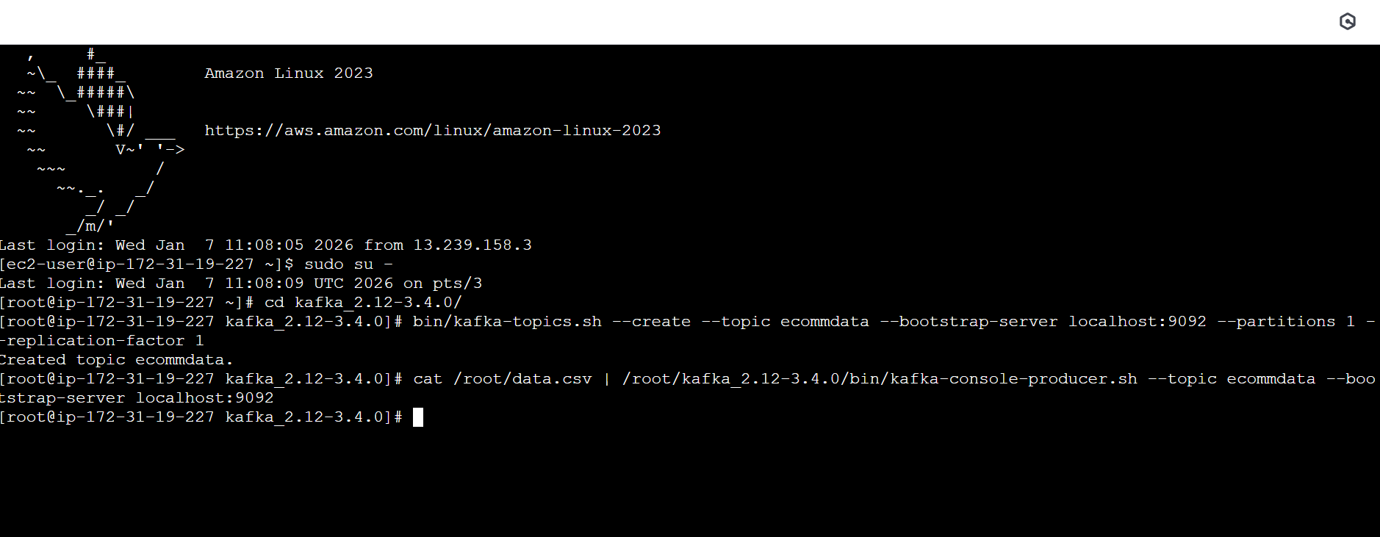
Step 3 - create a flink streaming program
from pyflink.datastream import StreamExecutionEnvironment
from pyflink.datastream.connectors.kafka import KafkaSource
from pyflink.common.serialization import SimpleStringSchema
from pyflink.common.watermark_strategy import WatermarkStrategy
env = StreamExecutionEnvironment.get_execution_environment()
source = KafkaSource.builder() \
.set_bootstrap_servers("localhost:9092") \
.set_topics("ecommdata") \
.set_group_id("flink-consumer") \
.set_value_only_deserializer(SimpleStringSchema()) \
.build()
ds = env.from_source(
source,
WatermarkStrategy.no_watermarks(),
"Kafka Source"
)
ds.print()
env.execute("Kafka to Flink Streaming")

Step 4 - ran the job on flink cluster
./bin/flink run -py kafka_flink_stream.py
(Flink deployed the job to the cluster connected to kafka started processing data in realtime)
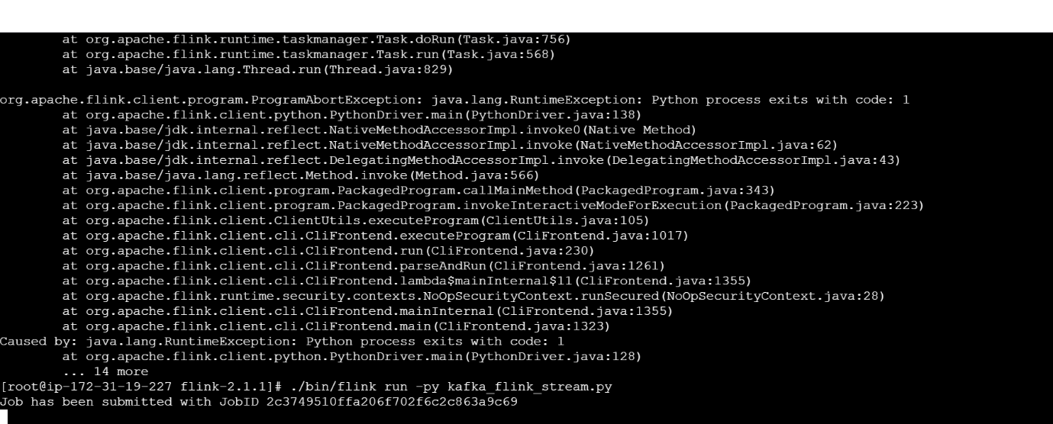
Step 5 – need to re run producer
cat /root/data.csv | /root/kafka_2.12-3.4.0/bin/kafka-console-producer.sh --topic ecommerce03 --bootstrap-server localhost:9092

